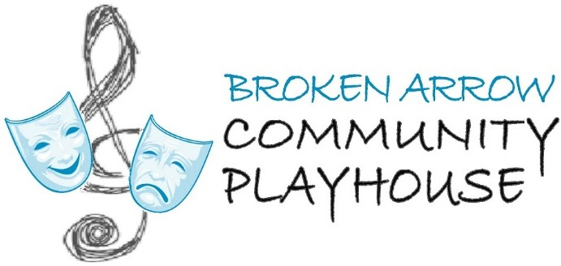

Broken Arrow Community Playhouse Usher Calendar 2024-2025

Please look over the calendar carefully and check the events you would like to usher for. You may either mail the form back to: BACP, PO Box 452, Broken Arrow, OK. 74013; email it to: [bacptheatre@aol.com;](mailto:bacptheatre@aol.com) drop it off in person at the Box Office (1800 S. Main Street) during business hours (see info below); or you may call in your selection to 918-258-0077.

BACP Box Office is open Tuesday-Friday 10 am – 2 pm.

Name:

Phone: Email:

Address:

* Call of availability to events are documented on a first come, first serve basis in the order the documents/information are returned.
* We don’t have a strict uniform policy but would encourage you to wear business casual attire unless we let you know that we are doing a costume or play specific attire. Like for Christmas, you can wear ugly sweaters or other festive holiday attire.
* Please keep in mind that dates and times are subject to change as well as cancellations.
* If you signed up for a date but cannot keep that commitment, please call the Box Office immediately so we have time to find a replacement.
* We will confirm your volunteer date and time about two weeks before the scheduled event.

Thank you for choosing to volunteer at the Broken Arrow Community Playhouse!

Broken Arrow Community Playhouse Season Shows for 2024-2025

|  |  |  |  |
| --- | --- | --- | --- |
| I want to usher | Date and Time | Show | Call time |
|  | Aug. 16 (Friday)  7:30 pm | All I Need to Know I Learned in Kindergarten | 6:30 pm |
|  | Aug. 17 (Saturday)  7:30 pm | All I Need to Know I Learned in Kindergarten | 6:30 pm |
|  | Aug. 18 (Sunday)  2 pm | All I Need to Know I Learned in Kindergarten | 1:00 pm |
|  | Aug. 23 (Friday)  7:30 pm | All I Need to Know I Learned in Kindergarten | 6:30 pm |
|  | Aug. 24 (Saturday)  7:30 pm | All I Need to Know I Learned in Kindergarten | 6:30 pm |
|  | Aug. 25 (Sunday)  2 pm | All I Need to Know I Learned in Kindergarten | 1:00 pm |
|  | Oct. 18 (Friday)  7:30 pm | Blithe Spirit | 6:30 pm |
|  | Oct. 19 (Saturday)  7:30 pm | Blithe Spirit | 6:30 pm |
|  | Oct. 20 (Sunday)  2 pm | Blithe Spirit | 1:00 pm |
|  | Oct. 25 (Friday)  7:30 pm | Blithe Spirit | 6:30 pm |
|  | Oct. 26 (Saturday)  7:30 pm | Blithe Spirit | 6:30 pm |
|  | Oct. 27 (Sunday)  2 pm | Blithe Spirit | 1:00 pm |
|  | Dec. 6 (Friday)  7:30 pm | A Tuna Christmas | 6:30 pm |
|  | Dec. 7 (Saturday)  7:30 pm | A Tuna Christmas | 6:30 pm |
|  | Dec. 8 (Sunday)  2:00 pm | A Tuna Christmas | 1:00 pm |

Broken Arrow Community Playhouse Season Shows for 2022-2023 Continued

|  |  |  |  |
| --- | --- | --- | --- |
|  | Dec. 13 (Friday)  7:30 pm | A Tuna Christmas | 6:30 pm |
|  | Dec. 14 (Saturday)  7:30 pm | A Tuna Christmas | 6:30 pm |
|  | Dec. 15 (Sunday)  2:00 pm | A Tuna Christmas | 1:00 pm |
|  | April 4 (Friday)  7:30 pm | On Golden Pond | 6:30 pm |
|  | April 5 (Saturday)  7:30 pm | On Golden Pond | 6:30 pm |
|  | April 6 (Sunday)  2 pm | On Golden Pond | 1:00 pm |
|  | April 11 (Friday)  7:30 pm | On Golden Pond | 6:30 pm |
|  | April 12 (Saturday)  7:30 pm | On Golden Pond | 6:30 pm |
|  | April 13 (Sunday)  2 pm | On Golden Pond | 1:00 pm |
|  | June 6 (Friday)  7:30 pm | Moon Over Buffalo | 6:30 pm |
|  | June 7 (Saturday)  7:30 pm | Moon Over Buffalo | 6:30 pm |
|  | June 8 (Sunday)  2 pm | Moon Over Buffalo | 1:00 pm |
|  | June 13 (Friday)  7:30 pm | Moon Over Buffalo | 6:30 pm |
|  | June 14 (Saturday)  7:30 pm | Moon Over Buffalo | 6:30 pm |
|  | June 15 (Sunday)  2 pm | Moon Over Buffalo | 1:00 pm |